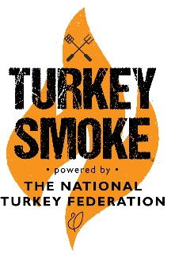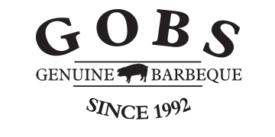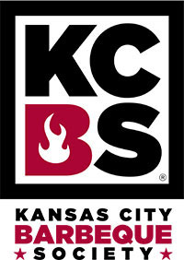

Greater Omaha Barbeque Society
28th Annual State BBQ Championship of Nebraska
GOBS QUE Back to Back August 13-14, 14-15, 2021,

The Greater Omaha Barbeque Society (GOBS) is proud to host its 28th contest in the Midwest. The 28th Annual State Barbeque Championship of Nebraska. Again this year we are enjoying a little bit of country and Blues at the Washington County Fairgrounds in Arlington Ne. We will be supporting several groups Camp Fontanelle and The Hope Center in Fremont.
Entry Form
Team Name: ____________________________________________________________________
Chief Cook: _____________________________________________________________________
Address: _______________________________________________________________________
City: ___________________________________________________________________________
Phone: (______)_________________________________________________________________
EMAIL: _____________________________________________________________________
KCBS # ___________________
Entry Fees:
_______ KCBS Entry GOBS Member (Chicken, Ribs, Pork, Brisket) $200 per contest before 07/17/2021
_______ KCBS Entry GOBS Member (Chicken, Ribs, Pork, Brisket) $225 after 07/17/2021
_______ KCBS Entry (Chicken, Ribs, Pork, Brisket) $225 per contest before 07/17/2021
_______ KCBS Entry (Chicken, Ribs, Pork, Brisket) $250 per contest after 07/17/2021
_______ KCBS Entry for all (Chicken, Ribs, Pork, Brisket) $400 for both contests
______ Site charge for 30 or 50 amp sites $20
______ Turkey Smoke Ancillary no charge and Turkey provided
______ Backyard Contest $100
______ Kids Que no charge how many ages 6 – 10 _____________ ages 11 -15 ________________
______ TOTAL DUE
Make Checks payable to: Greater Omaha Barbeque Society (GOBS)
Mail to: GOBS PO Box 271032 Omaha, Ne. 68127
Signature of Chief Cook: ________________________________________________
WAIVER OF LIABILITY: In consideration of your acceptance of this entry form and fee, I the undersigned intending to be legally bound, do hereby for myself, my heirs, executors and administrators, waive and release any and all rights and claims for damages I may have against GOBS, KCBS and the State Barbeque Championship of Nebraska and its sponsors for any and all injuries suffered by me or members of my group in this event. I further grant permission to the GOBS and/or agents authorized by them to use any photographs, videotapes or any other record of this event for any legitimate purpose.

