MEMBERSHIP RENEWAL / LIFETIME

GREATER OMAHA BARBEQUE SOCIETY

RENEWAL $30.00 _________
LIFETIME $300.00 _______
NAME: ____________________________________________________________________________________________________________

SPOUSE: __________________________________________________________________________________________________________

ADDRESS: ________________________________________________________________________________________________________

CITY/STATE/ZIP: ________________________________________________________________________________________________

PHONE: ___________________________________________ ALTERNATE PHONE: ______________________________________

EMAIL ADDRESS: ________________________________________________________________________________________________

BIRTHDAY [DAY AND MONTH ONLY] _________________________________________________________________________

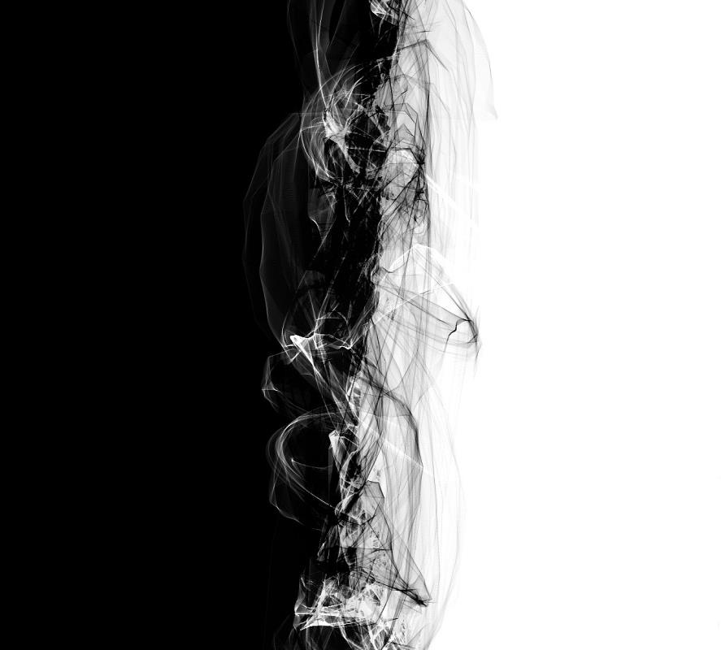
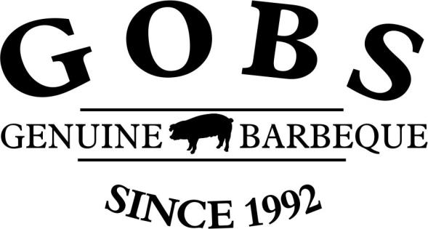
ARE YOU A MEMBER OF A COOKING TEAM? [ ] NO [ ] YES

TEAM NAME: ____________________________________________________________________________________________________

DO YOU HAVE A BBQ RELATED BUSINESS: [ ] NO [ ] YES

BUSINESS NAME: ________________________________________________________________________________________________

ARE YOU A KCBS CERTIFIED BBQ JUDGE? [ ] NO [ ] YES – KCBS # _____________________________________

ARE YOU A KCBS CERTIFIED TABLE CAPTAIN? [ ] NO [ ] YES – KCBS # _______________________________

CHECK ALL THAT APPLY TO YOUR INTEREST:

[ ] BACKYARD/AMATURE COMPETITION [ ] COMPETITION COOK TEAMS [ ] RESTAURANT [ ] CONTEST ORGANIZER [ ] CERTIFIED JUDGE [ ] RETAIL [ ] HEARTLAND CHALLENGE

[ ] OTHER _______________________________________________________________________________________________________

REFERRED BY: __________________________________________________________________________________________________

ARE YOU WILLING TO SPEND AT LEAST 2 DAYS PER CALENDAR YEAR SUPPORTING THE ORGANIZATION WITH EVENTS? [ ] YES [ ] NO

WOULD YOU LIKE TO BE ON OUR MASS EMAIL NOTIFICATION LIST SO THAT YOU MAY STAY UP TO DATE ON OUR EVENTS OR OTHER ACTIVITIES? [ ] YES [ ]NO
SEND COMPLETED APPLICATION TO: GREATER OMAHA BARBEQUE SOCIETY – PO BOX 271032 OMAHA, NEBRASKA 68127

