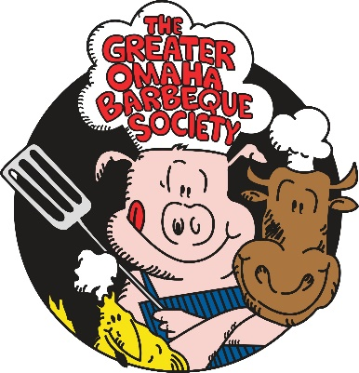
Backyard BBQ Bash

~~~~~~~~~~~ August 14, 2021 ~~~~~~~~~~

KCBS sanctioned Backyard BBQ competition
Washington County Fairgrounds, Arlington NE.

Team Name: ____________________________________________________
Team Captain: ____________________________________________________
Mailing Address: ____________________________________________________
City & State: ____________________________________________________
Telephone: ____________________________________________________
Email: ____________________________________________________

$100 Entry Fee Chicken option we provide will be 2 whole chickens Yes ____ No ______
You may provide your own chicken
20 AMP spots available no added fee. You may also use your own generators.

Make checks payable to Greater Omaha Barbeque Society
PO Box 271032 Omaha, Ne. 68127

Turn ins will coincide with professional teams and times will be announced at cooks meeting Saturday morning.

PAYOUT $500 Minimum
Payout will increase as the number of teams increases.

Waiver of Liability: In consideration of accepting this entry, I the undersigned, recognize that GOBS, nor anyone associated with this competition assume any responsibility for myself or members of my team or group. I will assume all risks that arise from participation. I also waive any claims against GOBS Backyard BBQ Bash l or anyone associated with this competition, its sponsors, their departments, officers, employees or agents from any injuries or loss that arise from participation. Furthermore, I grant full permission to GOBS Backyard BBQ Bash of that and/or any agent(s) authorized by them to use any photographs, video recordings, or any other record of this event for any legitimate purposes.

____________________________________________________________________ Team Captain Signature _________________ Date

