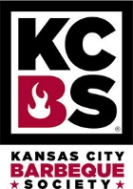 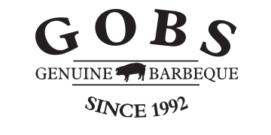 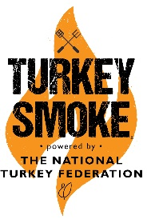 Greater Omaha Barbeque Society -- GOBS QUE
28th Annual Barbeque Championship of Nebraska
August 14 and 15, 2021
at Washington County Fairgrounds Arlington, Ne.
***** JUDGES APPLICATION *****
NAME: ADDRESS: CITY/STATE/ZIP CELL PHONE: ALT PHONE: EMAIL:
KCBS # EXP DATE:

ARE YOU A: JUDGE: [ ] MASTER JUDGE: [ ] TABLE CAPTAIN: [ ]
ARE YOU AVAILABLE : August 14 [ ] August 15 [ ] Both [ ]
ARE YOU AVAILABLE for Turkey Smoke August 14 [ ] after KCBS pro
IF YOU ARE A TABLE CAPTAIN, ARE YOU WILLING TO TABLE CAPTAIN THE CONTEST? [ ] YES [ ] NO
ARE YOU WILLING TO VOLUNTEER in JUDGES AREA IF NOT CHOSEN AS A JUDGE OR TC? [ ] YES [ ] NO
HOW MANY CONTESTS HAVE YOU JUDGED :
ARE YOU AN ACTIVE MEMBER OF THE GREATER OMAHA BBQ SOCIETY [ ] YES [ ] NO
***IMPORTANT NOTES***YOU MUST BE A KCBS CERTIFIED BBQ JUDGE WITH A CURRENT KCBS MEMBERSHIP AS OF THE DATE OF THE COMPETITION TO BE ACCEPTED.
- JUDGING APPLICATIONS WILL BE ACCEPTED UNTIL August 10th, 2021.
- SELECTED JUDGES WILL BE NOTIFIED BY EMAIL.
In consideration of you accepting this entry, I the undersigned, intending to be legally bound, hereby, for myself, my heirs, executors and administrators, waive and release any and all rights and claims for damages I may have against the contest city, Kansas City Barbecue Society, their representatives, successors, and assigns for any and all injuries suffered by me in or at this event. Further, I hereby grant full permission to contest personnel, the city in which the contest is held, Kansas City Barbecue Society or any authorized agents to use any photographs, videos, recordings, or any other record of the event for any legitimate reason. I understand the event organizer has the right to reject any application without explanation.

I AGREE TO ABIDE BY THE RULES AND REGULATIONS OF THE KANSAS CITY BARBECUE SOCIETY, AVAILABLE UPON REQUEST, OR AT WWW.KCBS.US AS WELL AS THE CITY THE EVENT IS IN.
SIGNATURE: DATE:

SEND APPLICATION TO: GOBS – ATTN: Judges Coordinator – PO Box 271032 – Omaha, Nebraska 68127 Or email to gobsjudges@gmail.com

